Dear Candidate,

Thank you for your time and interest in this position at Entrega Systems Group! To assist us in evaluating your skills, we’d like you to complete this short exercise. We want to emphasize that we care less about what you know coming in the door than your ability to learn new things and this will help us verify that.

You will should use the following technologies and services to complete this exercise:
- Amazon Web Services (Free for new users, http://aws.amazon.com/free/)
- Ubuntu Server 12.04 LTS (ami-82fa58eb) - This AMI is available from the Quick Launch Wizard on the AWS console.
- Cloud Init
- Puppet (in a standalone configuration)
- Apache HTTPD
- github

Your assignment is to create “user-data” to paste into the instance launch form on the AWS console to boot an EC2 micro instance (this is in the AWS “free tier” http://aws.amazon.com/free/), install Puppet, install and configure Apache HTTPD with a virtual host that responds to a request for “candidateeval.ithaka.org” (Note: we do not expect any DNS to be configured for this exercise).

Please make your user-data available to us via a git repository hosted on github.com. Create your own account, a new repository and send us the URL to your repo when you are done and we will try it on our EC2 account to validate your work.

This is how we will verify your work:

- Clone the git repo you provide from github
- Run ec2-run-instances ami-82fa58eb --instance-type t1.micro --key dev --user-data-file user-data.gz
- We’ll use ec2-describe-instances to get the public hostname
- Send an HTTP request to the machine with a specific host header: curl -v -H 'Host: candidateeval.ithaka.org' ‘http://public-ec2-address.aws.amazon.com’
- The web server response should return an html document that contains the text “Hello World” with a successful HTTP status code.

You are most welcome to ask us questions to clarify and complete this task! However, we believe there are sufficient online resources available to you.

Good luck and have fun!

Results:

Github:

https://github.com/marciwojcik/entrega_interview_wojcik.git
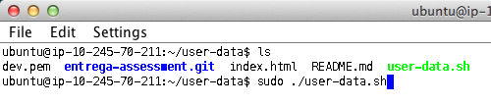

Tested: apache2 (i.e. httpd)
curl -v -H 'Host: candidateeval.ithaka.org’ ‘http://54.235.202.160’

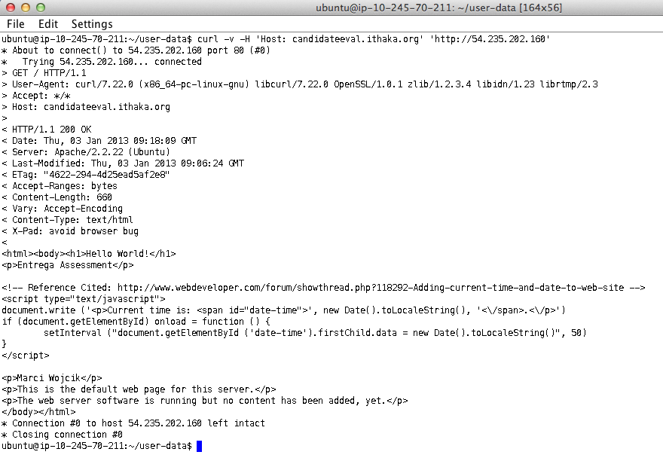
Tested: http://54.235.202.160

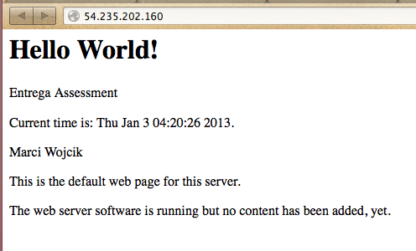

Quicklaunch/Classic Ubuntu Server 12.04 LTS (ami-82fa58eb)

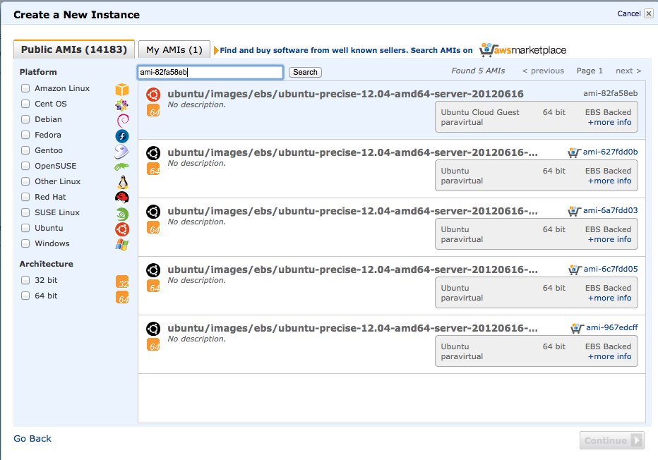

EC2 Management Console

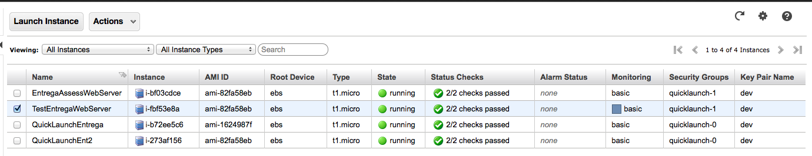

CloudInit (user-data.sh)
